PROJECT PROGRESS REPORT – 1

OFFICE MANAGEMENT SYSTEM

SMT B.K MEHTA IT CENTRE BCA COLLEGE
Submitted in partial fulfilment of the requirements for the degree of

BCA – Bachelors in Computer Application

Prepared By: Syed Sadiya Prepared By: Palray Rajvi Kaur
Roll No: 171 Roll No: 95
Exam No: 737 Exam No: 690

Under the Guidance of: Shri S. C. Malav
Date of Submission: April 16, 2026

1. Abstract
The Office Management System is a full-stack web application developed using the MERN Stack, which including MongoDB, Express.js, React.js and Node.js. The system is designed to manage office operations such as employee management, task assignment and attendance tracking. It provides a responsive user interface and efficient backend services, ensuring real-time data handling and improved productivity.

2. Objectives:
- To digitize office operations
- To manage employees efficiently
- To track tasks and attendance
- To reduce paperwork
- To provide reports

3. Project Progress (75%)
The project is approximately 75% completed with major modules implemented.
- UI completed
- Login system working
- Database connected
- Employee module done
- Task module done
- Dashboard ready

4. Database: Mongo DB
Collections:
4.1 Users Collection
Field Name | Type | Description
name | String | Stores user full name
email | String | Unique email for login
id | String | Employee ID
department | String | Department of employee
phoneno | String | Contact number
address | String | Residential address
password | String | Encrypted user password
role | String | Defines user role (admin/user)
createdAt | Date | Auto-generated timestamp
updatedAt | Date | Auto-updated timestamp

4.2 Tasks Collection
Field Name | Type | Description
title | String | Name of the task
assigned | String | Employee assigned to task
dueDate | String | Deadline of the task
status | String | Task status (pending, in-progress, completed)
priority | String | Priority level (Low, Medium, High)

4.3 Leave Collection
Field Name | Type | Description
name | String | Name of employee
type | String | Type of leave (sick, casual, etc.)
fromdate | Date | Leave start date
todate | Date | Leave end date
description | String | Reason for leave
status | String | Approval status (Pending/Approved/Rejected)
createdAt | Date | Auto timestamp
updatedAt | Date | Auto timestamp

4.4 Document Collection
Field Name | Type | Description
name | String | Name of the document
type | String | Type of file (PDF, DOC, Image)
path | String | File storage path
date | String | Upload date
createdAt | Date | Auto timestamp
updatedAt | Date | Auto timestamp

5. UML DIAGRAM

5.1. USE CASE DIAGRAM
The use case diagram shows the interaction between Admin and User with the system
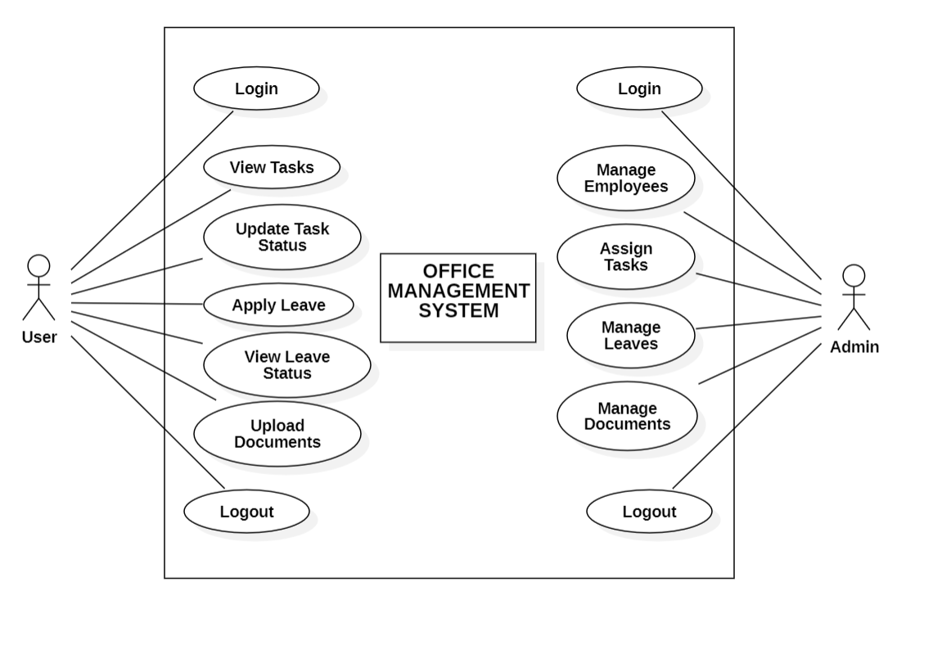

5.2. CLASS DIAGRAM
The class diagram represents the structure of the system with classes and relationships.
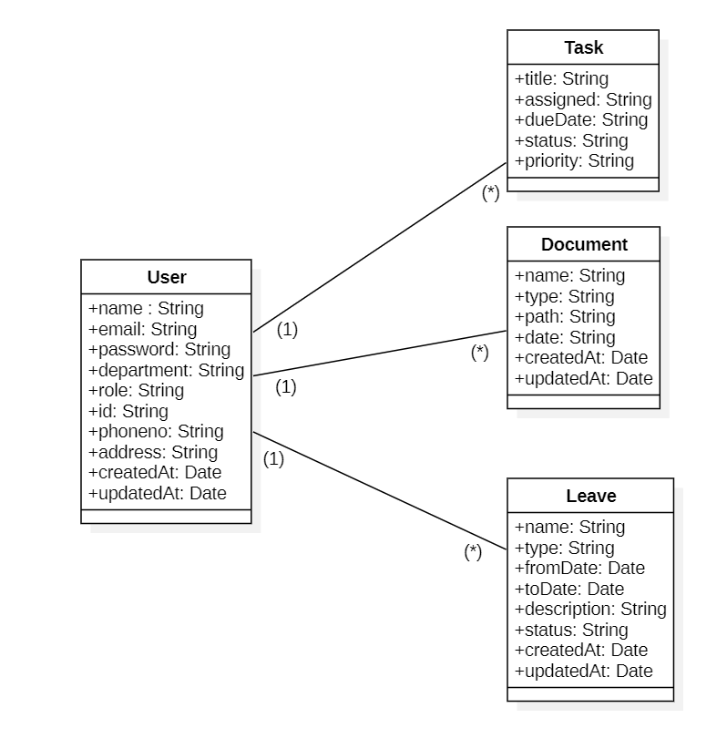

5.3. SEQUENCE DIAGRAM
It shows:
- Step-by-step flow of actions
- How system components interact over time

Login Sequence Diagram
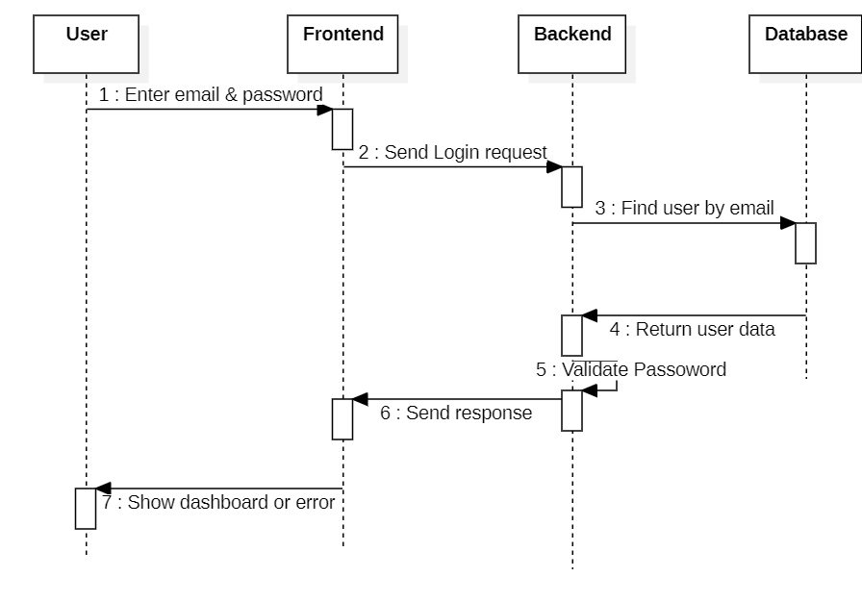

6. MAJOR MODULE DEVELOPED

1. Dashboard Module (Admin & Employee)
The dashboard module provides an overview of the system. The admin dashboard displays overall statistics such as total employees, tasks, and attendance records. The employee dashboard shows assigned tasks, attendance status, and personal activity summary.

2. Employee Management Module
This module allows the admin to manage employee records. It includes functionalities such as adding, updating, viewing, and deleting employee details. It helps in maintaining organized employee data within the system.

3. Task Management Module
This module enables the admin to assign tasks to employees and track their progress. Employees can view assigned tasks and update their task status. It ensures efficient task allocation and monitoring.

4. Department Management Module
This module allows the admin to create and manage different departments within the organization. Employees can be assigned to specific departments, which helps in better organization and management.

5. Attendance Management Module
This module is used to track employee attendance. The admin can monitor attendance records, while employees can mark their attendance and view their attendance history. It helps in maintaining accurate attendance data.

7. ISSUE FACED AND PLAN FOR COMPLETION

Issue Faced
During the development of the Office Management System, several challenges were encountered while implementing different modules of the system. Some of the major issues faced are listed below:
🔹 Issues:
- Difficulty in integrating frontend (React) with backend APIs (Node.js & Express)
- Errors while connecting and managing data in MongoDB database
- Handling user authentication and role-based access (Admin and Employee)
- Managing state and data flow in React components
- UI alignment and responsiveness issues
- Debugging errors in task and attendance modules

Plan for Completion
To complete the remaining part of the project, the following steps are planned:
🔹 Plan:
- Improve user interface and overall design of the system
- Implement proper validation and error handling
- Complete testing of all modules
- Fix remaining bugs and optimize performance
- Final integration of all modules
- Prepare documentation and finalize the project for submission

